Book recommendations for 2020
Book | Synopsis | NLB
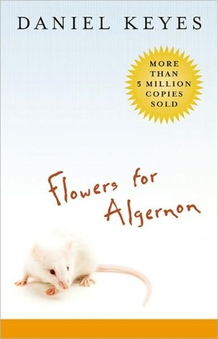 | Flowers for Algernon  by Daniel Keyes  Rating: 4.12  The story of a mentally disabled man whose experimental quest for intelligence mirrors that of Algernon, an extraordinary lab mouse. In diary entries, Charlie tells how a brain operation increases his IQ and changes his life. As the experimental procedure takes effect, Charlie's intelligence expands until it surpasses that of the doctors who engineered his metamorphosis. The experiment seems to be a scientific breakthrough of paramount importance--until Algernon begins his sudden, unexpected deterioration. Will the same happen to Charlie? | Yes
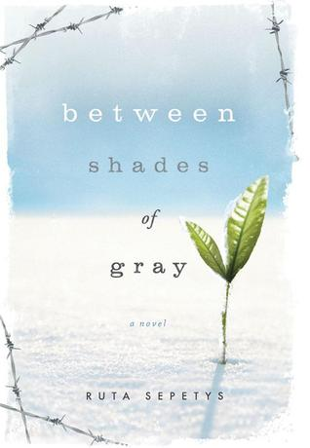 | Between Shades of Gray  by Ruta Sepetys (Goodreads Author)  Rating: 4.37  Lina is just like any other fifteen-year-old Lithuanian girl in 1941. She paints, she draws, she gets crushes on boys. Until one night when Soviet officers barge into her home, tearing her family from the comfortable life they've known. Separated from her father, forced onto a crowded and dirty train car, Lina, her mother, and her young brother slowly make their way north, crossing the Arctic Circle, to a work camp in the coldest reaches of Siberia. Here they are forced, under Stalin's orders, to dig for beets and fight for their lives under the cruelest of conditions. | Yes
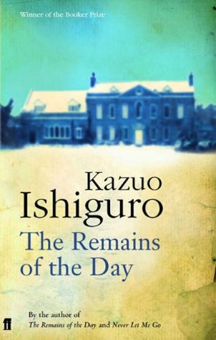 | The Remains of the Day  by Kazuo Ishiguro  Rating: 4.12  In the summer of 1956, Stevens, a long-serving butler at Darlington Hall, decides to take a motoring trip through the West Country. The six-day excursion becomes a journey into the past of Stevens and England, a past that takes in fascism, two world wars, and an unrealized love between the butler and his housekeeper. | Yes
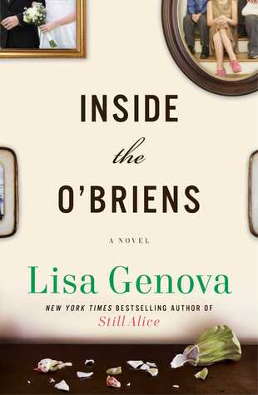 | Inside the O'Briens  by: Lisa Genova  Rating: 3.99  Joe O’Brien is a forty-four-year-old police officer from the Irish Catholic neighborhood of Charlestown, Massachusetts. A devoted husband, proud father of four children in their twenties, and respected officer, Joe begins experiencing bouts of disorganized thinking, uncharacteristic temper outbursts, and strange, involuntary movements. He initially attributes these episodes to the stress of his job, but as these symptoms worsen, he agrees to see a neurologist and is handed a diagnosis that will change his and his family’s lives forever: Huntington’s Disease. | Yes
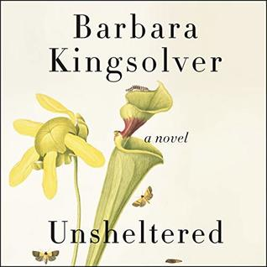 | Unsheltered  by Barbara Kingsolver  Rating: 3.61  The New York Times bestselling author of Flight Behavior, The Lacuna, and The Poisonwood Bible and recipient of numerous literary awards—including the National Humanities Medal, the Dayton Literary Peace Prize, and the Orange Prize—returns with a timely novel that interweaves past and present to explore the human capacity for resiliency and compassion in times of great upheaval. | Yes
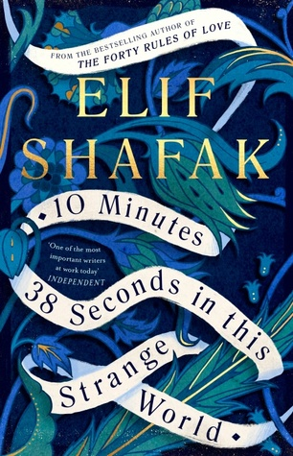 | 10 Minutes 38 Seconds in This Strange World  by Elif Shafak  Rating: 4.06  For Leila, each minute after her death brings a sensuous memory: the taste of spiced goat stew, sacrificed by her father to celebrate the long-awaited birth of a son; the sight of bubbling vats of lemon and sugar which the women use to wax their legs while the men attend mosque; the scent of cardamom coffee that Leila shares with a handsome student in the brothel where she works. Each memory, too, recalls the friends she made at each key moment in her life - friends who are now desperately trying to find her. | Yes
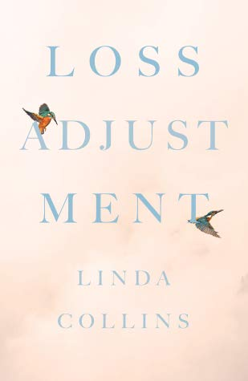 | Loss Adjustment  by Linda Collins  Rating: 4.36  Loss Adjustment is a mother’s recount of her 17-year-old daughter’s suicide.  Loss Adjustment involves the endless whys, the journey of Linda Collins and her husband in honoring Victoria, and the impossible question of what drove their daughter to this irretrievable act. A stunningly intimate portrait of loss and grief, Loss Adjustment is a breaking of silence—a book whose face society cannot turn away from. | Yes
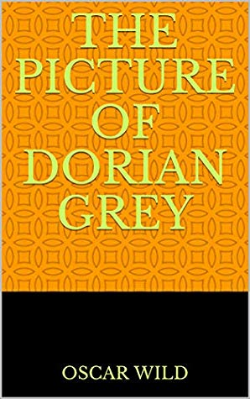 | The Picture of Dorian Grey  by Oscar wild  4.17 · Rating details · 71 ratings · 0 reviews  When a naïve young Dorian arrives in Victorian London, he is swept into a social whirlwind by the charismatic Lord Wotton, who introduces Dorian to the pleasures of the city. Henry's friend Basil Hallward paints a portrait of Dorian to capture the full power of his youthful beauty. When the portrait is unveiled, Dorian makes a flippant pledge: he would give anything to stay as he is in the picture - even his soul. (less) | Yes
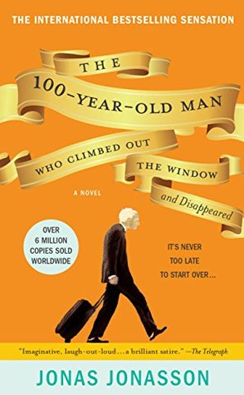 | The Hundred-Year-Old Man Who Climbed Out of the Window and Disappeared  by Jonas Jonasson  3.83 · Rating details · 190,223 ratings · 21,135 reviews  After a long and eventful life, Allan Karlsson ends up in a nursing home, believing it to be his last stop. The only problem is that he’s still in good health. A big celebration is in the works for his 100th birthday, but Allan really isn’t interested (and he’d like a bit more control over his alcohol consumption), so he decides to escape. He climbs out the window in his slippers and embarks on a hilarious and entirely unexpected journey. It would be the adventure of a lifetime for anyone else, but Allan has a larger-than-life backstory: he has not only witnessed some of the most important events of the 20th century, but actually played a key role in them. Quirky and utterly unique, The 100-Year-Old Man Who Climbed Out the Window and Disappeared has charmed readers across the world. (less) | Yes
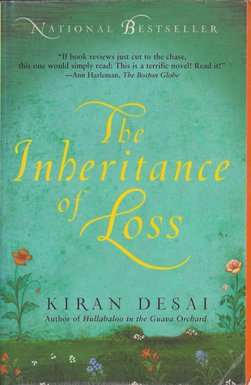 | The Inheritance of Loss  by Kiran Desai  Rating: 3.42  In a crumbling, isolated house at the foot of Mount Kanchenjunga in the Himalayas lives an embittered judge who wants only to retire in peace, when his orphaned granddaughter, Sai, arrives on his doorstep. The judge’s cook watches over her distractedly, for his thoughts are often on his son, Biju, who is hopscotching from one gritty New York restaurant to another. Kiran Desai’s brilliant novel, published to huge acclaim, is a story of joy and despair. Her characters face numerous choices that majestically illuminate the consequences of colonialism as it collides with the modern world. (less) | Yes
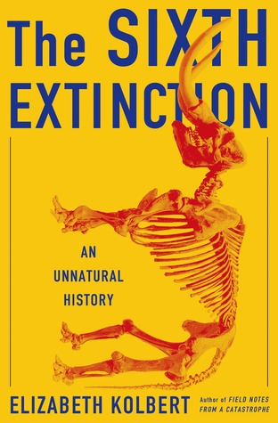 | The Sixth Extinction: An Unnatural History  by Elizabeth Kolbert  Rating: 4.13  Over the last half-billion years, there have been five mass extinctions, when the diversity of life on earth suddenly and dramatically contracted. Scientists around the world are currently monitoring the sixth extinction, predicted to be the most devastating extinction event since the asteroid impact that wiped out the dinosaurs. This time around, the cataclysm is us. | Yes
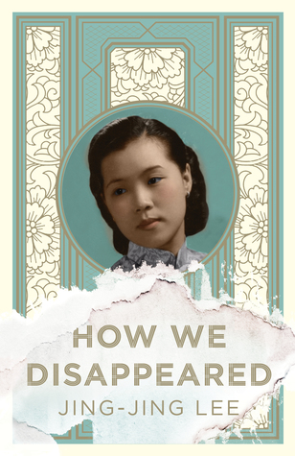 | How We Disappeared  by Jing-Jing Lee  Rating: 4.15  A beautiful, stunningly ambitious novel set in Singapore about a woman who survived the Japanese occupation and a man who thought he had lost everything. For fans of Min Jin Lee's Pachinko and Georgia Hunter’s We Were the Lucky Ones.  Singapore, 1942. As Japanese troops sweep down Malaysia and into Singapore, a village is ransacked, leaving only two survivors and one tiny child. | Yes
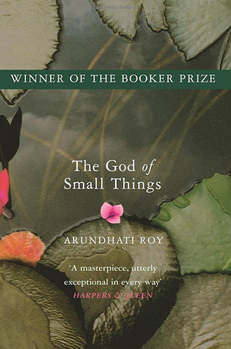 | The God of Small Things  by Arundhati Roy  Rating: 3.93  Compared favorably to the works of Faulkner and Dickens, Arundhati Roy’s debut novel is a modern classic that has been read and loved worldwide. Equal parts powerful family saga, forbidden love story, and piercing political drama, it is the story of an affluent Indian family forever changed by one fateful day in 1969. The seven-year-old twins Estha and Rahel see their world shaken irrevocably by the arrival of their beautiful young cousin, Sophie. It is an event that will lead to an illicit liaison and tragedies accidental and intentional, exposing “big things [that] lurk unsaid” in a country drifting dangerously toward unrest. Lush, lyrical, and unnerving, | Yes
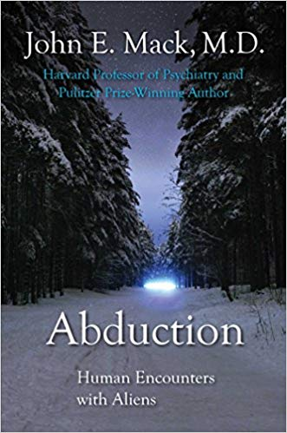 | Abduction: Human Encounters with Aliens Kindle Edition  by John E Mack  Rating: 4.4  A Harvard psychiatrist, the author of A Prince of Our Disorder, presents accounts of alien abduction taken from the more than sixty cases he has investigated and examines the implications for our identity as a species. | No
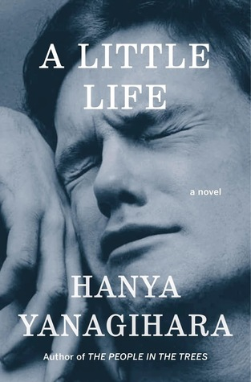 | A Little Life  by Hanya Yanagihara  Rating: 4.33When four classmates from a small Massachusetts college move to New York to make their way, they're broke, adrift, and buoyed only by their friendship and ambition. There is kind, handsome Willem, an aspiring actor; JB, a quick-witted, sometimes cruel Brooklyn-born painter seeking entry to the art world; Malcolm, a frustrated architect at a prominent firm; and withdrawn, brilliant, enigmatic Jude, who serves as their center of gravity. | Yes
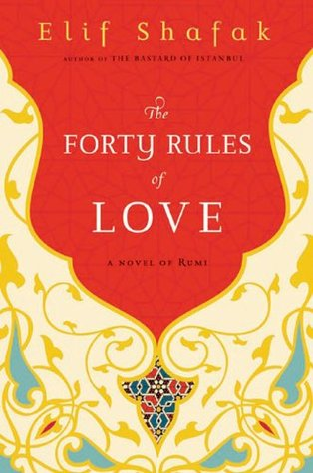 | The Forty Rules of Love  by Elif Shafak  Rating : 4.16  In this lyrical, exuberant follow-up to her 2007 novel, The Bastard of Istanbul, acclaimed Turkish author Elif Shafak unfolds two tantalizing parallel narratives—one contemporary and the other set in the thirteenth century, when Rumi encountered his spiritual mentor, the whirling dervish known as Shams of Tabriz—they together incarnate the poet's timeless message of love. | Yes
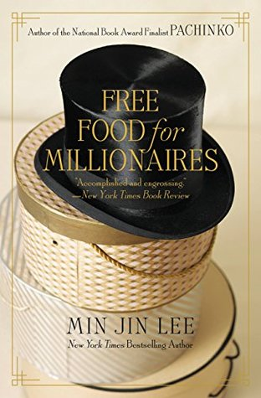 | Free Food for Millionaires  by Min Jin Lee  Rating: 3.16  The daughter of Korean immigrants, Casey Han has refined diction, a closeted passion for reading the Bible, a popular white boyfriend, and a magna cum laude degree in economics from Princeton, but no job and an addiction to the things she cannot afford in the glittering world of Manhattan. In this critically-acclaimed debut, Min Jin Lee tells not only Casey's story, but also those of her sheltered mother, scarred father, and friends both Korean and Caucasian, exposing the astonishing layers of a community clinging to its old ways and a city packed with struggling haves and have-nots. | Yes
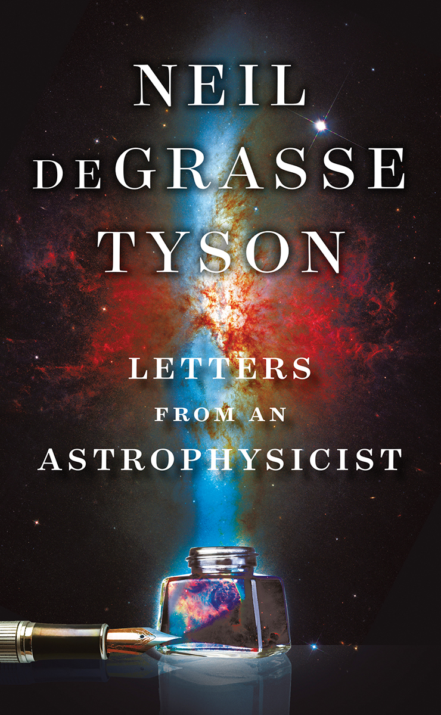 | Letters from an Astrophysicist  by Neil degrasse Tyson  Rating: 4.5  The natural follow-up to the phenomenal bestseller Astrophysics for People in a Hurry.  Astrophysicist Neil deGrasse Tyson has attracted one of the world’s largest online followings with his fascinating, widely accessible insights into science and our universe. Now, Tyson invites us to go behind the scenes of his public fame by unveiling his candid correspondence with people across the globe who have sought him out in search of answers. In this hand-picked collection of one hundred letters, Tyson draws upon cosmic perspectives to address a vast array of questions about science, faith, philosophy, life, and of course, Pluto. His succinct, opinionated, passionate, and often funny responses reflect his popularity and standing as a leading educator. | Yes
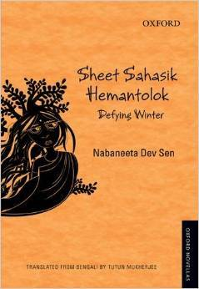 | Sheet Sahasik Hemantolok: Defying Winter  by : Nabneeta Dey Sen  Rating:4.1  Nabaneeta DevSen creates a series of individual women and their stories uncovering the lives lived and left behind. The last phase becomes the entry point for an artistic meditation on the inherent fragility of women's lives.  The novella examines the closed world of the relationships of women within their homes with all its bitterness, anger, intolerance and marvelously brings out its inevitable unfolding of power at different stages of a woman's lifespan. Here we see the tension between different generations of women as a clash of their dependence, both economic and emotional, on men. | No
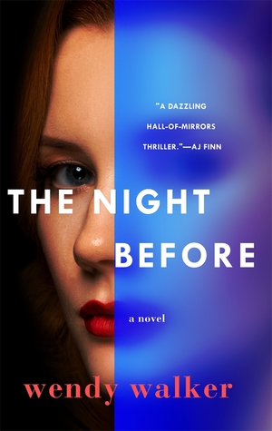 | The Night Before  by Wendy Walker  Rating:3.69  First dates can be murder.  Riveting and compulsive, national bestselling author Wendy Walker’s The Night Before “takes you to deep, dark places few thrillers dare to go” as two sisters uncover long-buried secrets when an internet date spirals out of control. | Yes
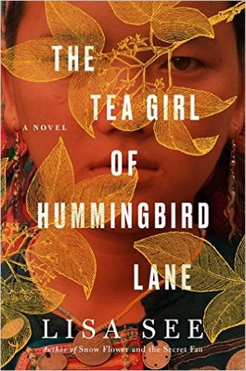 | The Tea Girl of Hummingbird Lane  by Lisa See  Rating:4.2  From #1 New York Times bestselling author Lisa See, “one of those special writers capable of delivering both poetry and plot” (The New York Times Book Review), a moving novel about tradition, tea farming, and the bonds between mothers and daughters.  A powerful story about circumstances, culture, and distance, The Tea Girl of Hummingbird Lane paints an unforgettable portrait of a little known region and its people and celebrates the bond of family. | Yes

